A La Carte Foods Available for Purchase to Complement School Meals
There have been many requests across the Division for PWCS to bring back a la carte food for purchase such as bottled water and cookies. In response to these requests, the Food and Nutrition Department will resume offering additional foods for purchase to complement school meals starting in March. These additional items include bottled water, freshly baked cookies, and packaged snacks such as baked chips, crackers, pretzels, and more. These new items all meet Smart Snack Guidelines (https://www.fns.usda.gov/tn/guide-smart-snacks-school) and meet our Division’s Clean Label Policy to not include any artificial colors, preservatives, sweeteners, and partially hydrogenated fat in our menu items. Students also have the opportunity to purchase second entrées, sides, and milk in addition to their first school breakfast and lunch.
The new a la carte options can be purchased using cash or can be charged to a school meal account if there are sufficient funds available in this account. Prices for these new a la carte items and information about setting up and managing school meal accounts can be found on the PWCS Nutrition website: https://pwcsnutrition.com/index.php?sid=0408101731444083&page=prepaidacct

PWCS Nutrition’s Harvest Of The Month Poster Contest
Would you like to see your artwork displayed across the Division?! The PWCS Food and Nutrition Department is kicking off their Harvest of the Month Art Contest in March in celebration of National Nutrition Month! Every month, PWCS Nutrition features a different fruit or vegetable as the Harvest of the Month. Students have the opportunity to illustrate one of these featured Harvest of the Month fruits or veggies. Winning illustrations will be displayed across the Division and featured on PWCS Nutrition’s social media accounts. Winners will be announced in the 2024-25 school year! Follow @PWCSNutrition on Twitter and Instagram to learn more and see the winning art!
Illustrations must be submitted using a specific contest entry form. Please ask your School Food Service Manager for the contest entry form. Submit contest illustrations to your School Food Service Manager by Friday, May 31st. If you have any questions, please contact Meghan Leineweber at leinewmj@pwcs.edu.

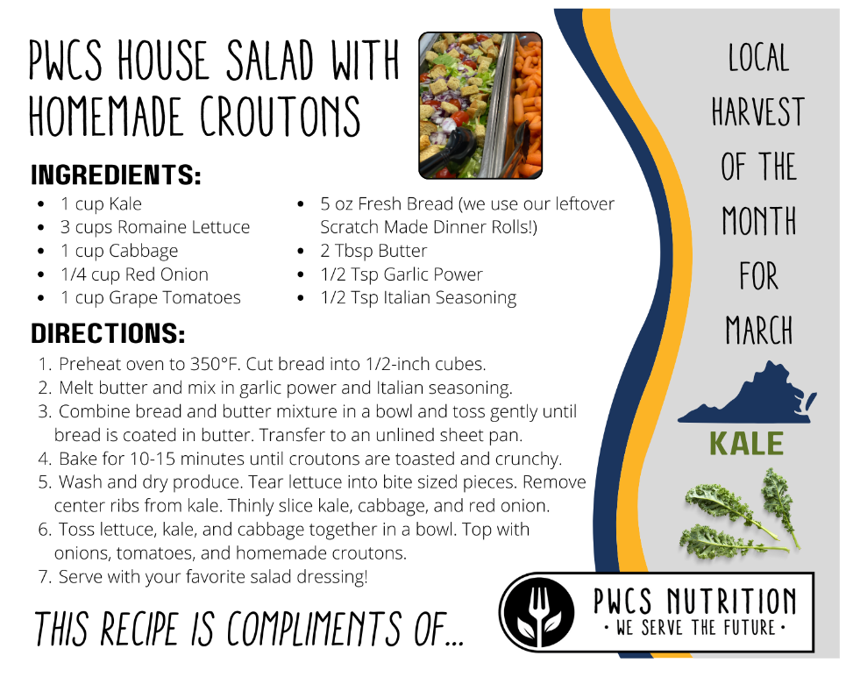
March Harvest Of The Month: Kale!
March’s Local Harvest of the Month is Kale! Here is the recipe for PWCS’s House Salad which contains kale and is topped with Homemade Croutons. Did you know that PWCS makes homemade croutons using their leftover Scratch Made Dinner Rolls? Here is the recipe for their House Salad with Homemade Croutons served on the Fresh Fruit and Vegetable Bars across the Division!

