Local Harvest of the Month Recipe: Curtido (served with Pupusas on the school lunch menu!)

The Harvest of the Month feature in November is Cabbage! In celebration of Cabbage, the Food and Nutrition Department is serving scratch made Curtido, a Salvadorian cabbage slaw, with Pupusas in November! Curtido is a traditional side served with Pupusas which are thick flatbreads filled with cheese and a variety of other ingredients. The Pupusas we will be serving are filled with beans and cheese! The Curtido recipe the PWCS Nutrition staff will be preparing for students was provided and developed by PWCS Food and Nutrition Employees who have family roots in El Salvador and Honduras. The recipe for the Curtido that will be served in schools is below! Pupusas and Curtido will be served on the following dates in November:
Elementary Schools: Tuesday, November 21st
Middle Schools: Tuesday, November 28th
High Schools: Wednesday, November 29th

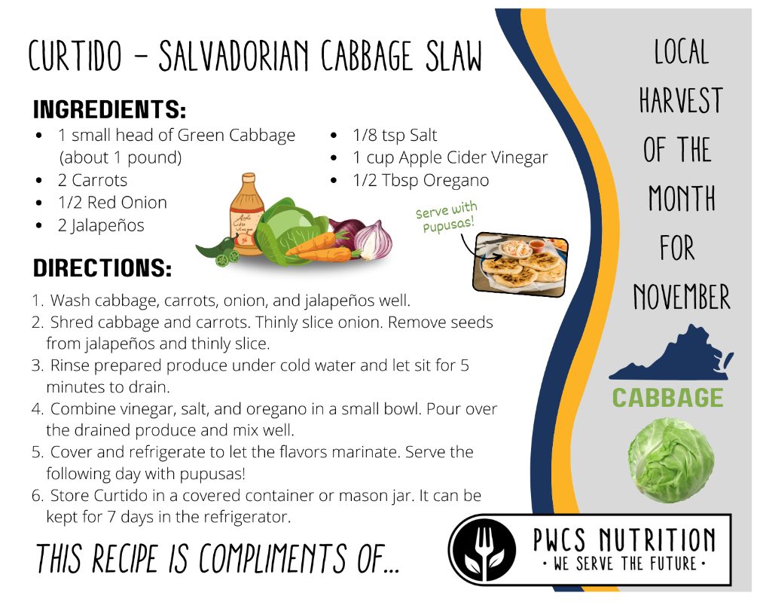

Thanksgiving Luncheon

The Food and Nutrition Department will be serving a festive Thanksgiving-themed meal in November! The menu includes, but is not limited to, Roast Turkey Breast, Mashed Potatoes and Gravy, Scratch-Made Dinner Rolls, Parmesan Broccolini, and Scratch-Made Pumpkin Souffle! Visit www.PWCSNutrition.com for the full menu. The special Thanksgiving menu will be served on the following dates. Please join us!
Elementary Schools: Thursday, November 9th
Middle and High Schools: Friday, November 17th

